**ASSIGNMENT 2**

Build a python code, Assume you get temperature and humidity values (generated with random function to variable) and write a condition to continuously detect alarm in case of high temperature.

**Program:**

import random

import winsound

temperature= random.randrange(0,100)

print(temperature)

if(temperature>60):

print("HIGH TEMPERATURE")

#print('\a')

winsound.Beep(4460, 10000)

else:

print("NORMAL TEMPERATURE")

difference=random.randint(3,8)

dewpoint=temperature-difference

print("dewpoint=",end=" ")

print(dewpoint)

#Relative Humidity

rh=100*(2.718281828*(17.625*dewpoint/(243.04+dewpoint)))/(2.718281828*(17.625*temperature/(243.04+temperature)))

print("Relative Humidity=",end=" ")

print(rh)

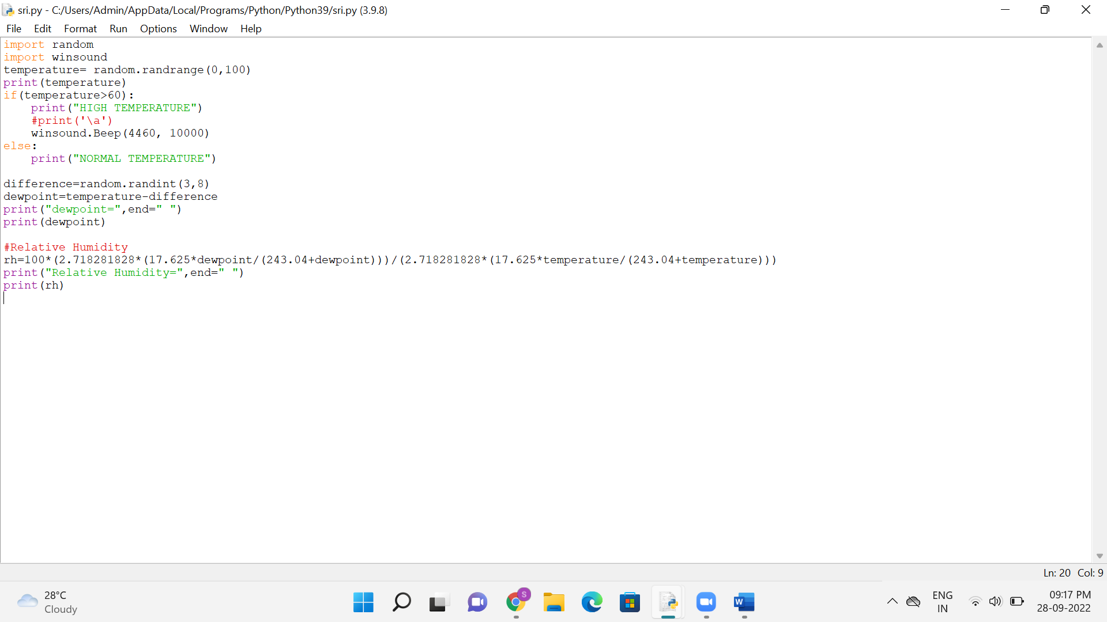

**Output:**

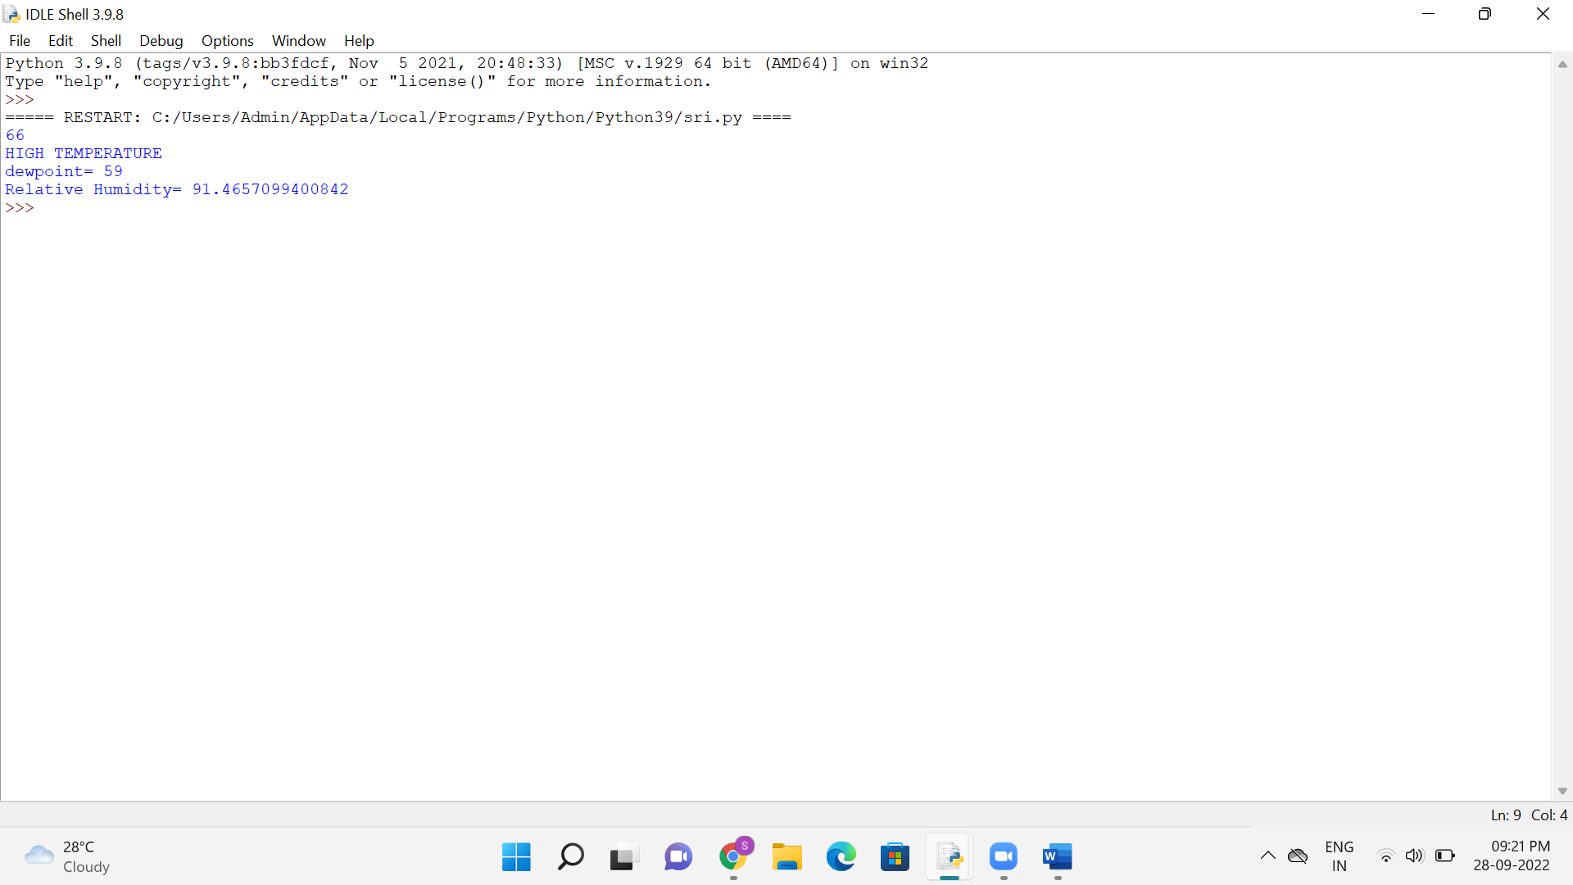

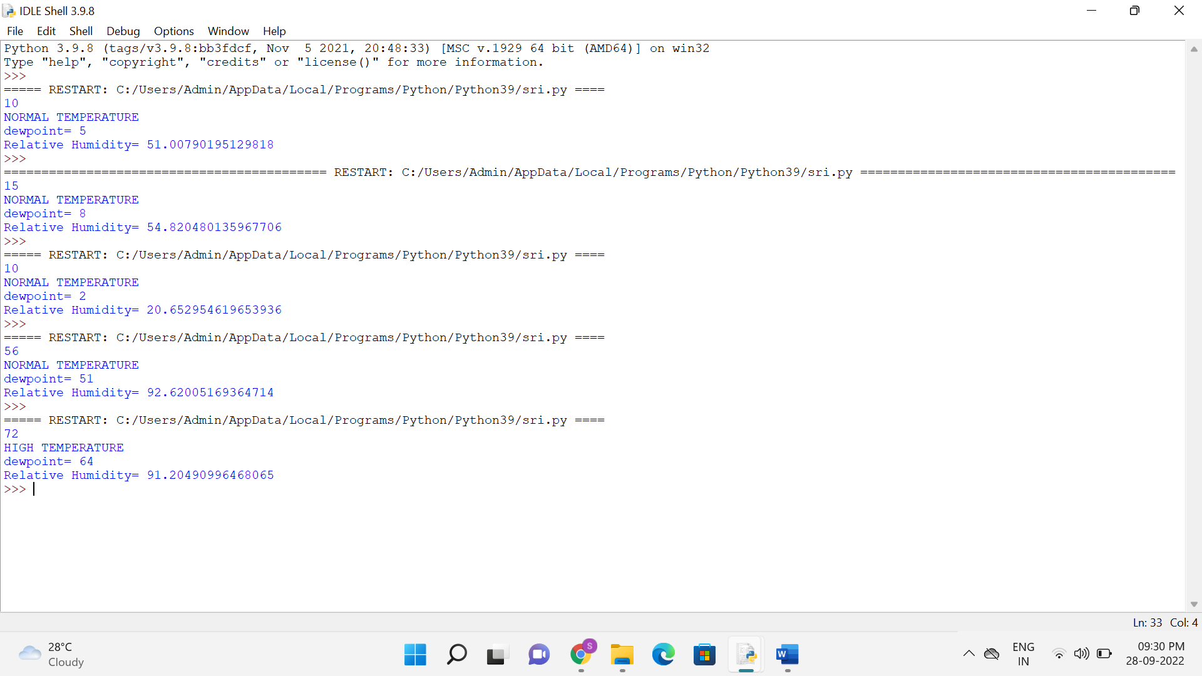

**Drive Link:**

https://drive.google.com/file/d/10WCMociekytmcwaZg-poDnsHbiihF4qc/view?usp=sharing